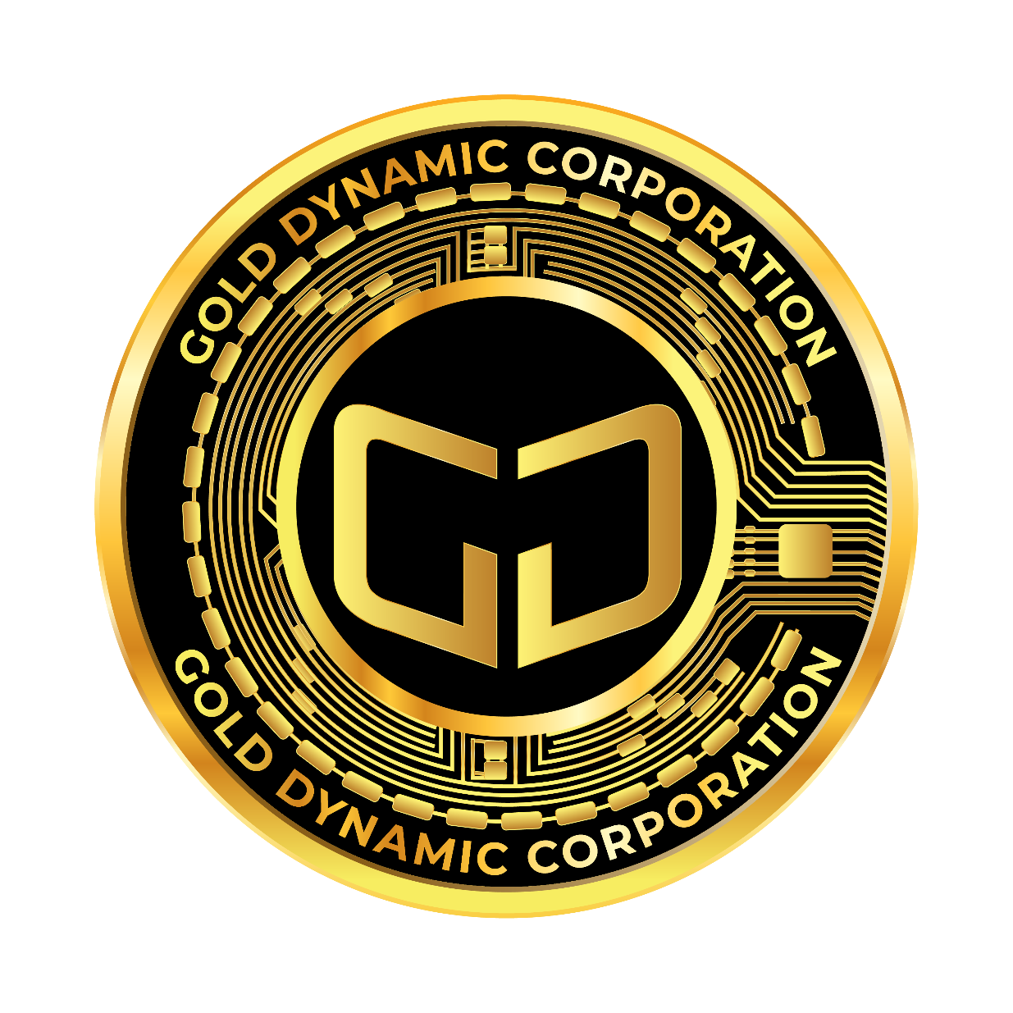

**GOLD DYNAMIC XCHANGE INTERNATIONAL**

**“ G D X I ”**

*“Where your future in Gold begins”*

August 29th, 2023

**The following document is provided for the benefit and the betterment of our clients and followers globally. We look forward to serving those who are looking to have a solid, even a more secure financial future. Even though we live in tumultuous times financially, there are real solutions which one can take to stop the roller-coaster ride that so many people are having to endure. We can and we will show you a better and more secure way forward for you and your family.**

Gold is Security

The **GDXI** token is the premium digital asset or token which is secured by real gold. In a world of uncertainty, gold can and will protect you and your family from the rigors of financial uncertainty. Fiat currencies can fail, and stocks may tumble, but gold will provide you with an anchor of safety and security. Something upon which you can rely.

A gold-backed cryptocurrency is a type of digital currency that is linked to the value of gold. Each unit of our cryptocurrency represents a certain amount of physical gold stored in reserves. The idea behind a gold-backed cryptocurrency is to combine the benefits of both traditional gold ownership and modern blockchain technology. Here is how it generally works:

Gold Reserves: A trustworthy entity, like a financial institution or a company, holds a certain amount of physical gold in reserves. This gold serves as the backing for the cryptocurrency. The amount of cryptocurrency in circulation is typically directly tied to the amount of gold held in storage.

Tokenization: The gold-backed cryptocurrency is tokenized on a blockchain. Each token, representing a fixed amount of gold (for example, 1 Jade token can equal 1 gram of gold), which is recorded and verified through blockchain technology.

Transparency and Security: Blockchain technology ensures transparency and security. Transactions are recorded on the blockchain, providing an immutable record of ownership and transfers. This transparency can help prevent fraud and maintain trust.

Exchange and Transactions: Users can buy, sell, and trade these gold-backed tokens on various cryptocurrency exchanges. The value of the cryptocurrency is tied to the current market value of gold. As the price of gold fluctuates, the value of the cryptocurrency will reflect those changes.

Stability and Hedging: Gold-backed cryptocurrencies offer a level of stability that is not typically seen with traditional cryptocurrencies like Bitcoin. Since their value is directly tied to gold, which has historically been a stable asset, they can act as a hedge against economic uncertainties and market volatility.

Ownership and Accessibility: Gold-backed cryptocurrencies provide a more accessible way for people to own gold. They eliminate the need for physical storage and handling of gold, making it easier for individuals to invest in and hold precious metals.

Auditing and Regulation: For the credibility of the cryptocurrency, regular audits of the gold reserves are essential to ensure that the claimed amount of gold exists. Additionally, regulatory compliance helps build trust and protect investors.

It is important to note that the success of a gold-backed cryptocurrency depends on the credibility and transparency of the entity managing the gold reserves, as well as the technological infrastructure supporting the tokenization and trading of the cryptocurrency. As with any investment, thorough research and understanding are crucial before getting involved with any form of cryptocurrency.

Follow the Yellow Brick Road

The role of gold as a hedge against financial turmoil and uncertainty is a perspective shared by many investors and economic analysts. Gold has historically been considered a safe haven asset, often sought-after during times of economic instability. There are several reasons why people view gold as a store of value and a form of financial protection.

**Limited Supply:** Gold is a precious metal with a finite supply. Its scarcity contributes to its value and makes it resistant to the inflationary pressures that can affect fiat currencies.

**Historical Store of Value:** Gold has been used as a store of value for centuries. Its enduring value has earned it a reputation as a "safe" asset that can preserve wealth over time.

**Diversification:** Adding gold to an investment portfolio can provide diversification, which can help reduce overall risk. During periods of economic downturns, the price of gold may move independently from other assets, offering a form of insurance against losses.

**Hedge Against Inflation:** While fiat currencies can be devalued over time due to inflation, the value of gold tends to hold relatively steady. This makes gold a potential hedge against the eroding purchasing power of money.

**Psychological Value:** Gold has cultural and psychological significance. People often associate it with value, stability, and security, which can contribute to its demand as an investment.

**Geopolitical Uncertainty:** Gold can serve as a hedge against geopolitical instability, as it holds value across borders and is not dependent on the stability of any single country's economy.

**Tangible Asset:** Unlike stocks or bonds, gold is a tangible asset. It does not rely on the performance of a company or the functioning of financial markets. This tangibility can be reassuring in times of uncertainty.

**Long-Term Preservation:** Throughout history, gold has weathered various economic crises, wars, and market crashes. This track record of long-term preservation contributes to its perceived reliability.

The road to your financial prosperity and security Is paved in gold. Many diverse types of investment have come and gone, various paper schemes have come and gone. But nothing has survived the rigors of time or circumstance better than gold. Nothing.

It may seem to some that gold is ‘old fashioned” as an investment, but even through the worst of human history, gold has provided the security and the safety for which it is famous.

Historic Safety

Even going back as far as Rome, gold has been used to secure and clearly preserve wealth. Gold is time tested and has proven itself as the safest guardian to protect wealth. Nothing is better.

**Ancient Civilizations:** Gold has been used as a form of currency and a store of value by ancient civilizations, including the Romans, Greeks, Egyptians, and many others. Its scarcity and resistance to corrosion made it a suitable medium for trade and a way to preserve wealth across generations.

**Tangible and Universal Value:** Gold's physical nature and universal recognition have contributed to its enduring value. It is universally accepted as valuable across cultures and regions, making it a reliable form of wealth preservation.

**Inflation Hedge:** Throughout history, gold has often served as a hedge against inflation. When the value of paper currencies diminishes due to inflation, gold's value tends to hold more steadily, making it a way to safeguard purchasing power.

**Crisis and Uncertainty:** During times of economic crisis, political instability, and war, people have turned to gold as a safe haven. Its ability to retain value in uncertain times has solidified its reputation as a wealth-preserving asset.

**Limited Supply:** Gold's scarcity is a significant factor in its value. Its limited supply ensures that it cannot be easily devalued through excessive production, unlike fiat currencies that can be printed in massive quantities.

**Financial Diversification:** Including gold in an investment portfolio can provide diversification, helping to reduce overall risk. When other assets like stocks or bonds face volatility, gold can act as a stabilizing force.

**Cultural Significance:** Gold has cultural and symbolic significance beyond its financial value. It has been used in jewellry, art, and religious objects for centuries, further cementing its place in history and society.

**Modern Relevance:** In contemporary times, gold continues to play a role as a portfolio diversifier and a hedge against economic uncertainty. Gold-backed investment products, like exchange-traded funds (ETFs) and gold-backed cryptocurrencies, provide more accessible ways for investors to participate.

While gold has demonstrated its resilience and value preservation qualities over time, it is important to recognize that no investment is entirely without risk. Gold prices can still experience short-term fluctuations due to market sentiment, global economic factors, and changes in investor behavior.

Ultimately, the decision to invest in gold or any other asset should be based on a thorough understanding of your financial goals, risk tolerance, and investment horizon. Diversification, careful research, and a long-term perspective are key to building a balanced and resilient investment strategy.

Indeed, the price of gold has exhibited significant volatility over the past year, with fluctuations between its high and low points. The factors influencing gold's price movements are multifaceted and can include macroeconomic trends, geopolitical developments, interest rate changes, currency movements, investor sentiment, and more. Let us briefly explore some of the factors that might have contributed to the recent price dynamics you mentioned:

**Pandemic-Driven Uncertainty:** The COVID-19 pandemic has introduced a high degree of uncertainty to global markets. Investors have turned to safe-haven assets like gold in search of stability during times of market turmoil.

**Economic Stimulus:** The substantial fiscal and monetary stimulus implemented by governments and central banks worldwide has raised concerns about inflation and the long-term value of fiat currencies. These concerns can drive demand for gold as a hedge against currency devaluation.

**Interest Rates:** The movement of interest rates, especially real interest rates (adjusted for inflation), can impact gold prices. When real interest rates are low or negative, gold becomes relatively more attractive as an investment because it does not generate interest or dividends but can maintain its value.

**Geopolitical Tensions:** Geopolitical events, such as tensions between nations or regions, can drive investors to seek safety in gold as a store of value.

**Dollar Strength:** The strength of the U.S. dollar can influence gold prices. When the dollar strengthens, gold prices may decrease as it becomes more expensive for holders of other currencies to purchase gold.

**Technical Analysis:** Technical factors, such as chart patterns and trading volumes, can also contribute to short-term price movements. Breakouts and breakdowns can be triggered by technical signals that influence traders' decisions.

**Supply and Demand Dynamics:** Physical supply and demand for gold can influence prices. Reduced production due to pandemic-related disruptions and changes in jewelry demand, for example, can impact the supply-demand balance.

**Investor Sentiment:** The collective sentiment of investors, driven by news, economic data, and market expectations, can play a significant role in short-term price movements

**Cryptocurrencies and Other Investments:** The emergence of cryptocurrencies and other alternative investments can divert some attention and funds away from traditional safe havens like gold.

It is worth noting that gold's price movements can be complex and multifaceted, often influenced by a combination of these a range of factors and more. As an investor, understanding these dynamics can provide insights into potential opportunities.

Security and Validation

GDXI is fast becoming the leader in gold backed crypto currency. All **GDXI** gold is hall-marked and serialized. It is kept in a secure location, under the care and protection of a Central Bank. Our gold is counted and has been validated for the security and comfort of our clients globally.

So in conclusion, there are significant opportunities for GDXI which needs to be considered:

**Innovation and Disruption:** Cryptocurrencies and blockchain technology have the potential to disrupt various industries, including finance, supply chain, healthcare, and more. They can enable more efficient, transparent, and secure processes.

**Financial Inclusion:** Cryptocurrencies can provide financial services to individuals who lack access to traditional banking systems. This can empower people in underserved regions to participate in the global economy.

**Decentralization:** The decentralized nature of cryptocurrencies can reduce the control of centralized authorities over financial transactions and information, giving more power to individuals.

**Smart Contracts:** Cryptocurrencies like Ethereum enable the creation of smart contracts, self-executing agreements with predefined rules. These contracts have applications in various sectors, from real estate to legal contracts.

**International Transactions:** Cryptocurrencies can facilitate cross-border transactions with reduced fees and faster settlement times compared to traditional methods.

In the context of cryptocurrency, the terms "coin" and "token" are often used to describe two different types of digital assets. While they are similar in some ways, they have distinct characteristics:

Coin: A coin is a digital currency that operates on its own independent blockchain. Examples of coins include Bitcoin (BTC), Ethereum (ETH), and Litecoin (LTC). These coins have their own blockchain networks, and they serve as both a medium of exchange and a store of value. Coins typically have their own native network and are used for various purposes, including peer-to-peer transactions, smart contracts (in the case of Ethereum), and more.

Token: A token, on the other hand, is a digital asset that is built on top of an existing blockchain platform, such as Ethereum. Tokens do not have their own independent blockchains; instead, they leverage the infrastructure of another blockchain. Tokens are often created as part of Initial Coin Offerings (ICOs) or Token Generation Events (TGEs) and can represent a variety of assets, such as ownership in a project, access rights, or even physical assets. Tokens can have different functionalities and use cases, including utility tokens that grant access to specific features of a platform, security tokens that represent ownership in a company, or non-fungible tokens (NFTs) that represent unique digital assets.

In summary, the key differences between coins and tokens are:

Coins have their own independent blockchains, while tokens are built on existing blockchains.

Coins are typically used as a form of currency or store of value, while tokens can represent various assets or rights.

Coins often have a broader use case as a medium of exchange, while tokens can have more specific and varied functions within a particular ecosystem or platform.

Stablecoins

A stablecoin is a type of cryptocurrency that is designed to maintain a relatively stable value, usually by being pegged to a specific reserve asset or a basket of assets. The primary purpose of stablecoins is to address the price volatility that is often associated with traditional cryptocurrencies like Bitcoin and Ethereum. Stablecoins aim to combine the benefits of cryptocurrencies, such as fast and borderless transactions, with the price stability of traditional fiat currencies or other stable assets.

There are a few different types of stablecoins, each using different mechanisms to maintain stability:

**Fiat-Collateralized Stablecoins:** These stablecoins are backed by reserves of traditional fiat currencies, such as the US Dollar or Euro, held in bank accounts or other custodial arrangements. Each stablecoin in circulation is typically backed by an equivalent amount of fiat currency.

**Crypto-Collateralized Stablecoins:** These stablecoins are backed by other cryptocurrencies, often in overcollateralized ratios to maintain stability. If the value of the backing cryptocurrencies falls below a certain threshold, mechanisms are in place to trigger corrective actions.

**Commodity-Collateralized Stablecoins:** Some stablecoins are backed by physical commodities like gold or silver. (**GDXI)**  Each token represents ownership of a certain amount of the underlying commodity.

**Algorithmic Stablecoins:** These stablecoins use algorithms and smart contracts to control their supply and demand dynamics, aiming to keep their price stable. For example, if the price goes too high, new coins might be created; if the price goes too low, coins might be burned.

Stablecoins offer various use cases within the cryptocurrency space, including:

**Medium of Exchange:** Stablecoins can be used for day-to-day transactions and remittances, providing a more stable unit of account compared to volatile cryptocurrencies.

**Store of Value:** Users can hold stablecoins as a relatively safe store of value, especially during times of market turbulence in the broader cryptocurrency space.

**Trading and Arbitrage:** Traders often use stablecoins to move funds quickly between exchanges to take advantage of price differences.

**Decentralized Finance (DeFi):** Stablecoins are commonly used in decentralized finance protocols for lending, borrowing, yield farming, and other financial activities.

It's important to note that while stablecoins aim for stability, external factors such as regulatory changes, financial risks, and technological vulnerabilities can still impact their value. As with any financial instrument, due diligence and understanding of the specific stablecoin's mechanics are essential.

In fact, a stablecoin can be either a coin or a token. The terms "coin" and "token" are often used interchangeably, but they can have slightly different connotations in the context of cryptocurrencies.

Coin: A coin is a cryptocurrency that operates on its own blockchain. Examples of coins include Bitcoin (BTC) and Ethereum (ETH). These cryptocurrencies have their own native blockchains and are not built on top of another blockchain.

Token: A token, on the other hand, is a digital asset that is built on an existing blockchain platform. The most common platform for issuing tokens is Ethereum, where many projects create tokens that adhere to the ERC-20 token standard. Tokens can represent various assets or functionalities and can have different use cases beyond being a currency.

When it comes to stablecoins, they can take the form of both coins and tokens:

Stablecoin Coin: Some stablecoins, like Tether (USDT) and TrueUSD (TUSD), have their own blockchains or platforms that they operate on, making them more like coins. These stablecoins have their own networks and protocols.

Stablecoin Token: Many stablecoins, including USD Coin (USDC) and DAI, are issued as tokens on existing blockchain platforms. For instance, USDC is an ERC-20 token on the Ethereum blockchain, while DAI is also an Ethereum-based token.

Whether a stablecoin is considered a coin or a token often depends on the blockchain platform it is built upon and how it operates within that platform's ecosystem. The choice of whether to issue a stablecoin as a coin or a token can influence factors such as interoperability, ease of use, and the existing infrastructure available on the chosen blockchain.

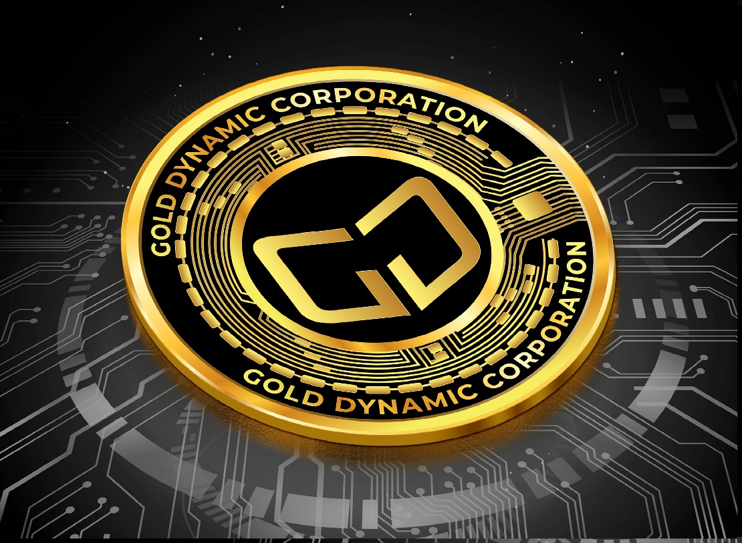

Terms & Conditions of Sale

(Title NO LINK)

Overall Considerations, Restrictions of Sale, Sophisticated Purchaser.

(Title - Link)

**IMPORTANT CONSIDERATIONS**

**Please read this section carefully. It contains important information about the nature, purpose and limitations of this whitepaper as well as what you acknowledge, accept and agree to should you choose to read this whitepaper.**

This whitepaper has been prepared by and for the benefit of Gold Dynamic Corporation (**Gold Dynamic**) and any affiliate or related entity of Gold Dynamic, and any natural or legal person or entity associated with any of them (collectively, **Gold Dynamic Associates**). This whitepaper is confidential and by the reader accepting delivery of this document, you agree to keep confidential all information contained herein. This whitepaper is a marketing document and is not intended to be legally binding. It is also not a representation or warranty of any kind by any Gold Dynamic Associate including about any Gold Dynamic Associate, the Gold Dynamic tokens (**GDXI tokens**), or any services, products, or operations of any Gold Dynamic Associate. The information in this whitepaper does not constitute an encouragement, inducement, advice, or a recommendation by any person to purchase the GDXI tokens or any other cryptographic token or currency and neither Gold Dynamic nor any Gold Dynamic Associate has authorized any person to make any such encouragement, inducement, advice, or recommendation. Nothing in this whitepaper shall be deemed to constitute a prospectus of any sort or a solicitation for investment, nor does it in any way pertain to an offering or a solicitation of an offer to buy any securities in any jurisdiction. Any offer or sale of GDXI tokens or any related instrument will occur only on Gold Dynamic's terms of sale and service, which are available (as at the date of this whitepaper) at gold.tether.to/legal (the **Terms**) and may be withdrawn or modified at any time. Interested parties should, amongst other things, conduct their own investigations and analysis of Gold Dynamic and GDXI tokens, and seek further information and professional advice as to its use and value. In particular, persons contemplating purchasing GDXI tokens should **review the Terms, including the risk disclosure statement referenced in, and forming a part of the Terms.** The Terms will apply to purchasers regardless of whether they purchase GDXI tokens directly from Gold Dynamic or in a secondary market transaction.

**Restricted Persons.** The sale of GDXI tokens is not directed at, and each purchaser of GDXI tokens will be required to represent, among other things, that they are not: (a) a citizen, resident (tax or otherwise) of, a person located or domiciled in, or any entity organized in or owned by certain persons in (i) the United States, or (ii) Cuba, Democratic People’s Republic of Korea (North Korea), the Government of Venezuela, Iran, Pakistan, Syria, or Crimea (a region of Ukraine annexed by the Russian Federation); (b) a person under the age of 18 years, and (c) any other persons who are "Prohibited Persons" as defined in the Terms (any such person falling under (a), (b) or (c), a **Restricted Person**). You must make your own assessment as to your ability to purchase GDXI tokens pursuant to laws applicable to you and to confirm that you are not a Restricted Person. No registration or other action has been or will be taken in any jurisdiction that would, or is intended to, permit the sale of GDXI tokens in any country or jurisdiction where registration or other action for that purpose is required. None of Gold Dynamic or any Gold Dynamic Associate makes any representation or warranty to any potential purchaser of GDXI tokens as to the legality of a purchase of GDXI tokens by such purchaser under the laws applicable to such purchaser.

**Purchaser Sophistication.** GDXI tokens are speculative and involve a high degree of risk and uncertainty. The sale of GDXI tokens is aimed solely at persons who have sufficient knowledge and understanding of blockchain and cryptographic tokens and other digital assets, smart contracts, storage mechanisms (such as digital or token wallets), and blockchain or distributed ledger technology, to be able to evaluate the risks and merits of a purchase of GDXI tokens and are able to bear the risks thereof, including loss of all amounts paid and loss of all GDXI tokens purchased. Potential purchasers must independently assess, after making such investigations as they consider necessary, the merits of, and their suitability for, purchasing any GDXI tokens. Potential purchasers and should consult their accounting, legal and tax representatives and advisers in order to evaluate the economic, legal and tax consequences of purchasing GDXI tokens.

**No Representations, Warranties or Liability.** Recipients of this whitepaper must not rely on information contained in this whitepaper or any inferences drawn from it. Purchasers of GDXI tokens must determine for themselves the information they require and base any decision on their own information, investigation, analysis and advice and not on the information contained in this whitepaper. No Gold Dynamic Associate makes or purports to make, and each hereby disclaims, any representation, warranty, condition, covenant or undertaking (whether express or implied) in any form whatsoever to any entity or person, including any representation, warranty or undertaking in relation to the truth, accuracy and completeness of any of the information set out in this whitepaper. In particular, no Gold Dynamic Associate makes any representation or warranty (whether express or implied) as to the accuracy or the completeness of the information contained in this whitepaper, and none of them have any liability for any statement, forecast, information or matter, express or implied, arising out of or contained in or derived from, or for any omission from this whitepaper or any other information communicated to any person in relation to or in connection with the matters contained in this whitepaper. To the maximum extent permitted by any and all applicable laws, no Gold Dynamic Associate shall be liable for any direct, indirect, special, incidental, consequential, punitive or other losses of any kind, in tort, contract, equity, common law or otherwise (including but not limited to loss of revenue, income or profits, and loss of use or data), arising out of or in connection with any acceptance of or reliance on this whitepaper or any part thereof. For clarity, no regulatory authority has examined or approved of any of the information set out in this whitepaper. No such action has been or will be taken under the laws of any jurisdiction. Gold Dynamic reserves the right to modify and replace GDXI tokens from time to time in its sole discretion and has no obligation to update this whitepaper, including to reflect any such modification or replacement.

**Private Presentation.** Neither this whitepaper, or any part of it, may be reproduced, distributed or disseminated by any person other than those persons authorized to do so by Gold Dynamic, and in each case such materials must include this section. This whitepaper, and any part or copy of it, must not be taken or transmitted to any country where distribution or dissemination of this whitepaper is prohibited or restricted at law or by Gold Dynamic.

Forward Looking Statements, Risk factors, Confidentiality.

(Title = Link)

**Forward Looking Statements** Certain statements contained in this whitepaper may constitute forward-looking statements or speak to future events or plans. These forward-looking statements or information involve known and unknown risks and uncertainties, which may cause actual events to differ materially. No reliance should be placed on any forward-looking statements or information.

No Representations, Warranties or Liabilities,

(Title - Link)

**Risk Factors.** Purchasing the GDXI tokens entails risks and purchasers could lose their entire purchase amount or all of their GDXI tokens. Certain risks are described in the risk disclosure statement that is referenced in and forms a part of the Terms.

**Your Promises, Representation and Warranties** By accessing, receiving or accepting possession of this whitepaper (or any part of it), you acknowledge, agree, represent and warrant to Gold Dynamic that: (1) you have read and understood the risk disclosure statement that is referenced in and forms a part of the Terms; (2) that you are not a Restricted Person; (3) the distribution or dissemination to you of this whitepaper, and any part of it, or its receipt or acceptance by you, is not prohibited or restricted by the applicable laws in your jurisdiction, and where any restrictions in relation to your receipt, acceptance or possession are applicable, you have and will observe and comply with all such restrictions at your own expense and without liability to any Gold Dynamic Associate ; and (4) all of the matters set out in, referred to in these Important Considerations is accepted and understood by you.

**WHAT IT WILL LOOK LIKE ON THE WEB…**

Terms & Conditions of Sale

(Title)

Overall Considerations, Restrictions of Sale, Sophisticated Purchaser.

(Title – Link; POST THE TEXT ABOVE WITH THIS SECTION)

Forward Looking Statements, Risk factors, Confidentiality.

(Title = Link POST THE TEXT ABOVE WITH THIS SECTION)

No Representations, Warranties or Liabilities,

(Title – Link TO POST THE TEXT ABOVE WITH THIS SECTION)

EACH SECTION WILL BE ITS OWN PAGE.